*Project: Event Management System using PostgreSQL.*

*Objective: To develop the application that allows users to create and manage events, track attendees, and handle event registrations efficiently. The project will include the following tasks:*

1. *Database Creation*
2. *Create a database named "EventsManagement"*

CREATE DATABASE EventsManagement;  
 *b) Create tables for Events, Attendees, and Registrations.  
c) Events- Event_Id, Event_Name, Event_Date, Event_Location, Event_Description*

CREATE TABLE Events (Event_Id SERIAL PRIMARY KEY,  
Event_Name TEXT NOT NULL,  
Event_Date DATE NOT NULL,  
Event_Location TEXT NOT NULL,  
Event_Description TEXT);

*d) Attendees- Attendee_Id, Attendee_Name, Attendee_Phone, Attendee_Email, Attendee_City*

CREATE TABLE Attendees (Attendee_Id SERIAL PRIMARY KEY,  
Attendee_Name TEXT NOT NULL,  
Attendee_Phone TEXT NOT NULL,  
Attendee_Email TEXT NOT NULL,  
Attendee_City TEXT NOT NULL);

*e) Registrations-Registration_id, Event_Id, Attendee_Id,Registration_Date,Registration_Amount.*

CREATE TABLE Registrations (Registration_Id SERIAL PRIMARY KEY,  
Event_Id INT REFERENCES Events(Event_Id),  
Attendee_Id INT REFERENCES Attendees(Attendee_Id),  
Registration_Date DATE NOT NULL,  
Registration_Amount NUMERIC);

1. *Data Creation Insert some sample data for Events, Attendees, and Registrations tables with respective fields.*

INSERT INTO Events (Event_Name, Event_Date, Event_Location, Event_Description)  
VALUES ('Medical Conference', '2024-07-15', 'Bangalore', 'National medical conference'),  
('Music Festival', '2024-08-20', 'Chennai', 'Indian Folk Music festival'),  
('Tech Expo', '2024-07-2', 'Bangalore', 'Latest Technology Exhibition'),  
('Auto Expo', '2024-09-10', 'Mumbai', 'Car and automobile exhibition');

INSERT INTO Attendees (Attendee_Name, Attendee_Phone, Attendee_Email, Attendee_City)  
VALUES ('Narendra Modi', '9846745665', 'the.pm@email.com', 'Delhi'),  
('Amit Shah', '9868665477', 'the.hm@email.com', 'Gandhinagar'),  
('Nirmala Sitharaman', '9656774311', 'the.fm@email.com', 'Chennai'),  
('Rahul Gandhi', '9856776588', 'opposition@email.com', 'Amethi');

INSERT INTO Registrations (Event_Id, Attendee_Id, Registration_Date, Registration_Amount)  
VALUES (1, 1, '2024-06-25', 100.00),  
(2, 2, '2024-06-26', 150.00),  
(3, 3, '2024-06-26', 100.00),  
(4, 4, '2024-06-27', 50.00);

1. *Manage Event Details  
   a) Inserting a new event.*

INSERT INTO Events (Event_Name, Event_Date, Event_Location, Event_Description)

VALUES ('Furniture Expo', '2024-09-11', 'Chennai', 'International Furniture Exhibition');  
 *b) Updating an event's information.*

UPDATE Events SET Event_Location = 'Delhi'

WHERE Event_Id = 4;  
 *c) Deleting an event.*

-- First, deleting the corresponding rows in the Registrations table  
DELETE FROM Registrations WHERE Event_Id = 1;  
-- Then, deleting the event from the Events table  
DELETE FROM Events WHERE Event_Id = 1;  
  
*4) Manage Track Attendees & Handle Events  
a) Inserting a new attendee.*INSERT INTO Attendees (Attendee_Name, Attendee_Phone, Attendee_Email, Attendee_City)

VALUES ('Malik Kharge', '9876887699', 'party.president@email.com', 'Bangalore');  
 *b)Registering an attendee for an event.*INSERT INTO Registrations (Event_Id, Attendee_Id, Registration_Date, Registration_Amount)

VALUES (2, 5, '2024-07-01', 200.00);

*5.Develop queries to retrieve event information, generate attendee lists, and calculate event attendance statistics.  
  
a) Generate a List of Attendees for a Specific Event (e.g., Event_Id = 2)*

SELECT a.Attendee_Name, a.Attendee_Email, a.Attendee_City  
FROM Attendees a  
JOIN Registrations r ON a.Attendee_Id = r.Attendee_Id  
WHERE r.Event_Id = 2;

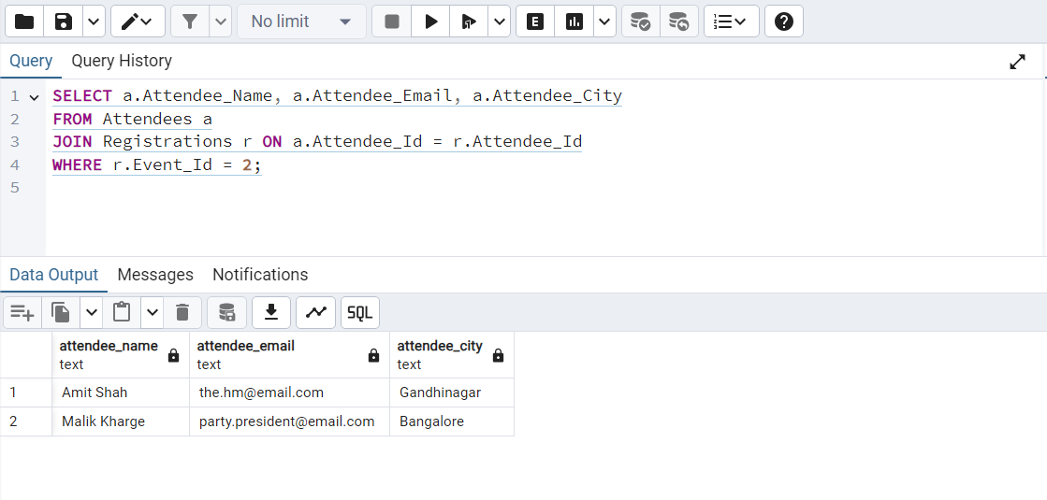

1. *Calculate the Total Number of Attendees for Each Event*

SELECT e.Event_Name, COUNT(r.Attendee_Id) AS Total_Attendees  
FROM Events e  
LEFT JOIN Registrations r ON e.Event_Id = r.Event_Id  
GROUP BY e.Event_Name;

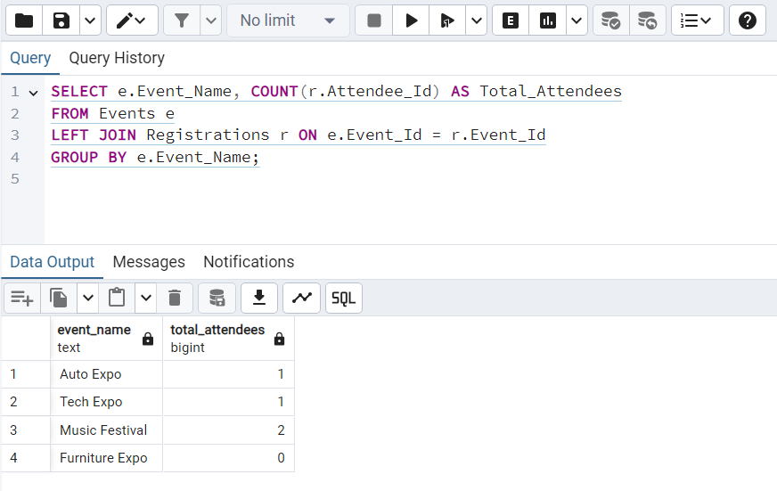

1. *Calculate the Total Registration Amount Collected for Each Event*

SELECT e.Event_Name, SUM(r.Registration_Amount) AS Total_Registration_Amount  
FROM Events e  
JOIN Registrations r ON e.Event_Id = r.Event_Id  
GROUP BY e.Event_Name;

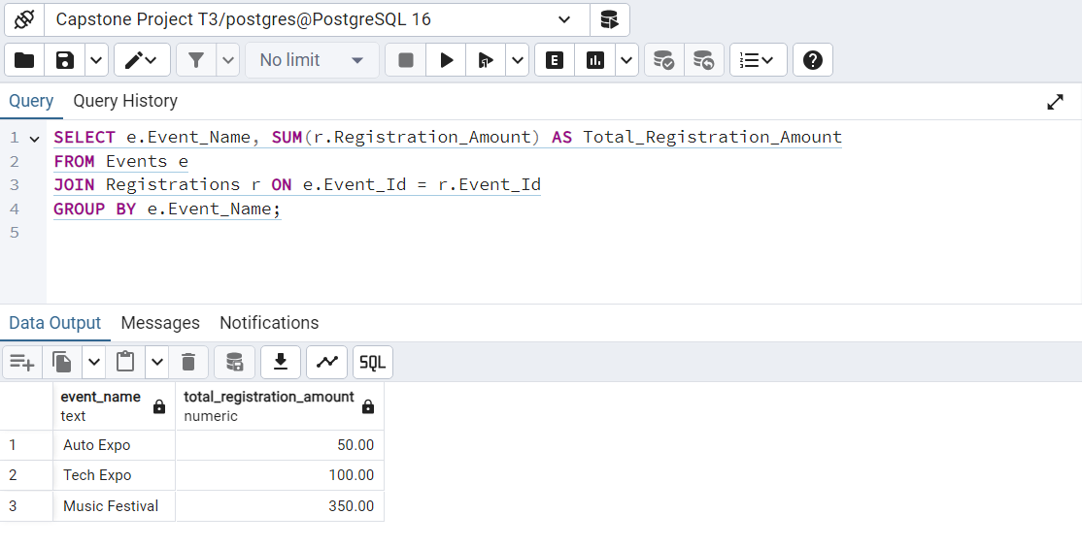

1. *Calculate the Maximum and Minimum Registration Amount Collected for Each Event*

SELECT e.Event_Name,   
MAX(r.Registration_Amount) AS Max_Registration_Amount,  
MIN(r.Registration_Amount) AS Min_Registration_Amount  
FROM Events e  
JOIN Registrations r ON e.Event_Id = r.Event_Id  
GROUP BY e.Event_Name;

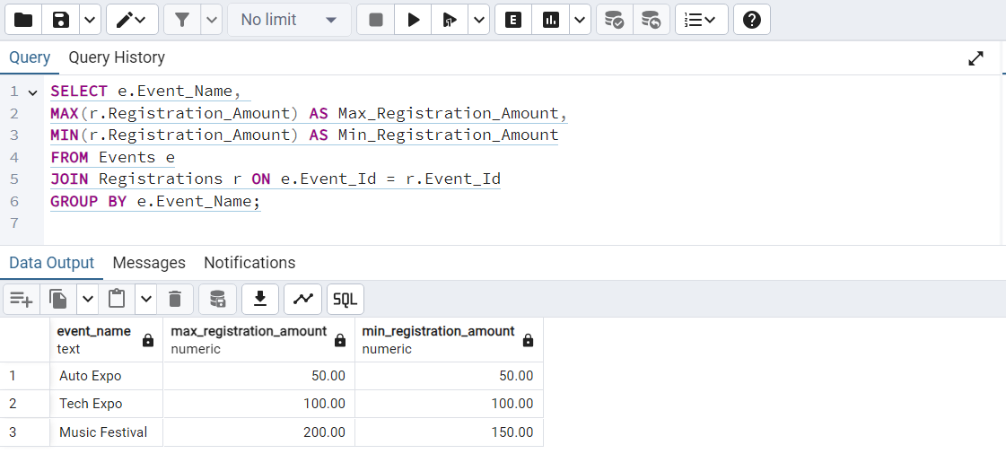

1. *List Events and Their Corresponding Attendee Count Grouped by Event Location*

SELECT e.Event_Location, e.Event_Name, COUNT(r.Attendee_Id) AS Total_Attendees  
FROM Events e  
LEFT JOIN Registrations r ON e.Event_Id = r.Event_Id  
GROUP BY e.Event_Location, e.Event_Name;

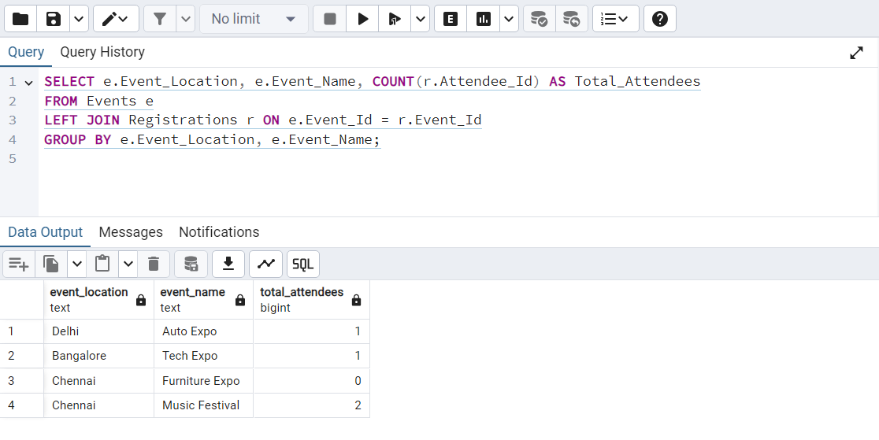

*f) Calculate the Total Number of Events an Attendee Has Registered For*

*SELECT a.Attendee_Name, COUNT(r.Event_Id) AS Total_Events  
FROM Attendees a  
JOIN Registrations r ON a.Attendee_Id = r.Attendee_Id  
GROUP BY a.Attendee_Name;*

